Problem Solving and Programming in C Laboratory
Assignment 1: Programs using sequential Constructs
Learning Outcome:
To apply the following basic features of C
- Data type declarations
- I/O statements
- Operators and expressions

Assignment:
Implement C programs for the following problem statements
--------------------------------------------------------------------------------------------------------------------------------------
1. Program to convert temperature from Celsius to Fahrenheit and vice versa using the following formula:
F = (C*9/5) +32

Test case 1:
Enter temperature in Celsius
36.56
Temperature in Fahrenheit = 97.808

Test case 2:
Enter temperature in Fahrenheit
97.808
Temperature in Celsius = 36.56

#include <stdio.h>
#include <stdint.h>

void fah_to_cel(void);
void cel_to_fah(void);

double cel,fah;

int main(){
cel_to_fah();

fah_to_cel();

return 0;
}

void fah_to_cel(void)
{
printf("Enter temperature in Fahreneit: ");
scanf("%lf",&fah);

cel= (fah-32.0)*(5.0/9.0);
printf("Temperature in Celsius: %.2f \n\n",cel);

}

void cel_to_fah(void)
{
printf("Enter temperature in Celsius: ");
scanf("%lf",&cel);

fah= (cel*(9.0/5.0))+32.0;
printf("Temperature in Fahreneit: %.2f\n\n",fah);
}

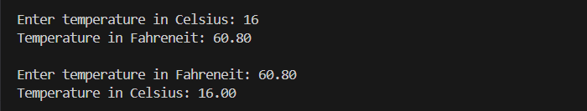

2. Write a C program to find the sum of digits of a three-digit number

Test case 1:
Enter a single three-digit number
257
Sum is 14

#include <stdio.h>

void sum_of_3_digits(int num);

int main() {
int num;

printf("Enter a single three-digit number: ");
scanf("%d", &num);

sum_of_3_digits(num);
return 0;
}

void sum_of_3_digits(int num)
{
int sum = 0;
while (num != 0) {
sum += num % 10;
num /= 10;
}
printf("Sum is %d\n", sum);
}

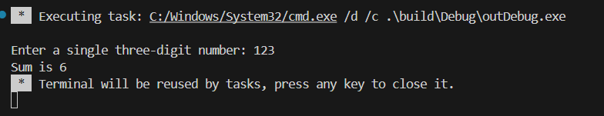
3. Program to input the values of two variables a and b and swap / interchange the
values.

Test case 1:
Enter the value of a
10
Enter the value of b
20
Before swapping: a = 10, b = 20
After swapping: a = 20, b = 10
Note: Values of variables must be updated. No marks will be awarded for simply changing
the order of printing variables.

#include <stdio.h>

void swap(int *a, int *b);

int main() {
int a, b;

printf("Enter the value of a: ");
scanf("%d", &a);
printf("Enter the value of b: ");
scanf("%d", &b);

printf("Before swapping: a = %d, b = %d\n", a, b);

swap(&a, &b);

printf("After swapping: a = %d, b = %d\n\n", a, b);

return 0;
}

void swap(int *a, int *b) {
int temp = *a;
*a = *b;
*b = temp;
}
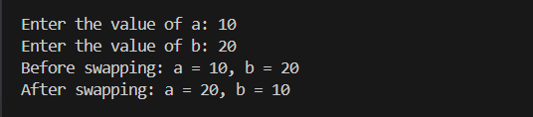

4. Program to input seconds and convert seconds into hh:mm:ss format
Test case 1:
Enter the seconds
4378
The time in hh:mm:ss format is : 1:12:58
Test case 2:
Enter the seconds 738
The time in hh:mm:ss format is : 0:12:18

#include <stdio.h>

void convert_seconds(int total_seconds);

int main() {
int total_seconds;

printf("Enter the seconds: ");
scanf("%d", &total_seconds);

convert_seconds(total_seconds);

return 0;
}

void convert_seconds(int total_seconds) {
int hours, minutes, seconds;

hours = total_seconds / 3600;
total_seconds %= 3600;
minutes = total_seconds / 60;
seconds = total_seconds % 60;

printf("The time in hh:mm:ss format is : %d:%d:%d\n\n", hours, minutes, seconds);
}

5. Sharon is traveling from city P to city Q. The distance between the two cities is a
variable because she would like to use the equation for other cities also. She knows
that she will be travelling half the distance at a speed of 40 miles per hour, and that
the remaining half will be travelled at 55 miles per hour. Calculate the time that it will
take to travel from one city to the next.
Test Case 1:
• Input: distance = 160
• Expected Output:
o Time for the first half =2 hours
o Time for the second half ≈1.45 hours
o Total Time: 2+1.45=3.45 hours

#include <stdio.h>

int main() {
float distance, half_distance;
float speed1 = 40.0; // speed for the first half
float speed2 = 55.0; // speed for the second half
float time1, time2, total_time;

// Input the distance between the two cities
printf("Enter the distance between city P and city Q (in miles): ");
scanf("%f", &distance);

// Calculate half the distance
half_distance = distance / 2.0;

// Calculate time for the first half
time1 = half_distance / speed1;

// Calculate time for the second half
time2 = half_distance / speed2;

// Calculate total time
total_time = time1 + time2;

// Output the results
printf("Time for the first half = %.2f hours\n", time1);
printf("Time for the second half = %.2f hours\n", time2);
printf("Total Time: %.2f hours\n\n", total_time);

return 0;
}
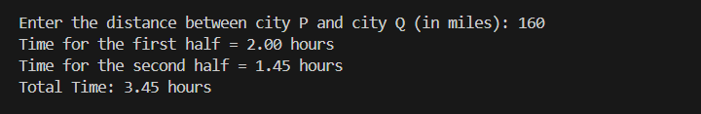

Challenging Programs:
6. Emily has taken a loan from a bank to buy a new car. The loan has a fixed annual
interest rate, and Emily wants to calculate her monthly payment to better plan her
finances. To determine the monthly payment, she needs to consider the total loan
amount, the annual interest rate, and the number of years over which she will repay
the loan. Emily needs to calculate the monthly payment using the formula for a fixed
rate loan:
Monthly Payment = 𝑷 × 𝒓 × (𝟏 + 𝒓)𝒏/(𝟏 + 𝒓)𝒏 - 𝟏
where:
P is the total loan amount Emily has taken
r is the monthly interest rate, calculated as annual interest rate/12
n is the total number of monthly payments, calculated as years×12

#include <stdio.h>
#include <math.h>

int main(){
double P, r, n,monthly_payment;
double total_loan, annual_interest_rate, total_years;

printf("Total Loan Amount:");
scanf("%lf",&total_loan);
printf("Annual Interest Rate:");
scanf("%lf",&annual_interest_rate);
printf("Number of Years for Repayment:");
scanf("%lf",&total_years);

P=total_loan;

r=(annual_interest_rate/12.0)/100.0;
n=(total_years*12.0);
double base=(1.0+r);
double temp=pow(base,n);
monthly_payment=(P*r*temp)/(temp-1);

printf("Monthly Payment: %.3f\n\n",monthly_payment);
}

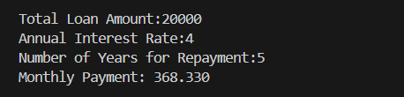

7. You are given a certain amount of money in rupees, and you need to calculate the
number of currency notes required to make that exact amount using the following
denominations: 500 rupees, 200 rupees, 100 rupees, 50 rupees, and 10 rupees. If it is
not possible to match the exact amount with the given denominations, calculate and
display the maximum achievable amount and the remaining amount that cannot be
represented. Write a C program that calculates and prints the number of notes needed
for each denomination and handles the case where the exact amount cannot be
matched.
Test Case 1:
• Input: amount = 1380
• Expected Output:
o 500 rupees notes: 2
o 200 rupees notes: 1
o 100 rupees notes: 1
o 50 rupees notes: 1
o 10 rupees notes: 3
o Remaining amount: 0
Test Case 2:
• Input: amount = 125
• Expected Output:
o 500 rupees notes: 0
o 200 rupees notes: 0
o 100 rupees notes: 1
o 50 rupees notes: 0
o 10 rupees notes: 2
o Remaining amount: 5

#include <stdio.h>

int main(){

int amount;

printf("Input: Amount = ");
scanf("%d",&amount);

int five_100 = amount/500;
printf("500 rupees notes: %d\n",five_100);

amount%=500;
int two_100 = amount/200;
printf("200 rupees notes: %d\n",two_100);

amount%=200;
int one_100 = amount/100;
printf("100 rupees notes: %d\n",one_100);

amount%=100;
int fifty = amount/50;
printf("50 rupees notes: %d\n",fifty);

amount%=50;
int ten = amount/10;
printf("10 rupees notes: %d\n",ten);

amount%=10;
printf("Remaining amount: %d\n\n",amount);

return 0;
}

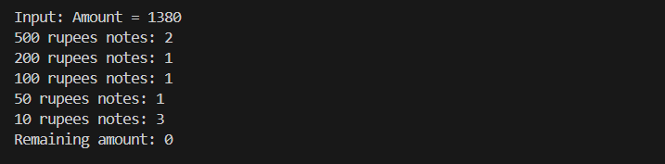

8. You need to calculate the total cost of painting a room with a given length, width, and
height. The paint coverage is given in square meters per litre. The cost of paint is
provided per litre. Consider the room has four walls and a ceiling, but not the floor.
The final bill should include a discount and tax calculations. The output must be a
detailed bill including quantity sold, price per item, amount, discount, discounted
total, tax, and total amount.
Test Case:
Inputs:
• Length of the room: 5.0 meters
• Width of the room: 4.0 meters
• Height of the room: 3.0 meters
• Paint coverage: 12.0 square meters per litre
• Cost per litre of paint: 40.0 Rs
• Discount percentage: 15.0%
• Tax percentage: 10.0%
Output:
******************* BILL **********************
Quantity Sold: 6.17 litres
Price per litre: Rs.40.00 -------------------------------------------------------------------------
Amount: Rs.246.67
Discount: Rs.37.00
Discounted Total: Rs.209.67
Tax: Rs.20.97 -------------------------------------------------------------------
Total Amount: Rs.230.64

#include <stdio.h>

int main(){
double length, width, height;
double paint_coverage, cost_per_litre;
double discount_percentage, tax_percentage;

printf("Length of the room (in meters): ");
scanf("%lf",&length);
printf("Width of the room (in meters): ");
scanf("%lf",&width);
printf("Height of the room (in meters): ");
scanf("%lf",&height);
printf("Paint coverage (in square meters per litre): ");
scanf("%lf",&paint_coverage);
printf("Cost per litre of paint (in Rs): ");
scanf("%lf",&cost_per_litre);
printf("Discount percentage: ");
scanf("%lf",&discount_percentage);
printf("Tax percentage: ");
scanf("%lf",&tax_percentage);

double area_walls = 2 * height * (length + width);
double area_ceiling = length * width;
double total_area = area_walls + area_ceiling;

double litres_needed = total_area / paint_coverage;
double amount = litres_needed * cost_per_litre;
double discount = (discount_percentage / 100.0) * amount;
double discounted_total = amount - discount;
double tax = (tax_percentage / 100.0) * discounted_total;
double total_amount = discounted_total + tax;

printf("\n******************* BILL **********************\n");
printf("Quantity Sold: %.2f litres\n", litres_needed);
printf("Price per litre: Rs.%.2f\n", cost_per_litre);
printf("---------------------------------------------------------\n");
printf("Amount: Rs.%.2f\n", amount);
printf("Discount: Rs.%.2f\n", discount);
printf("Discounted Total: Rs.%.2f\n", discounted_total);
printf("Tax: Rs.%.2f\n", tax);
printf("---------------------------------------------------\n");
printf("Total Amount: Rs.%.2f\n\n", total_amount);

return 0;
}
